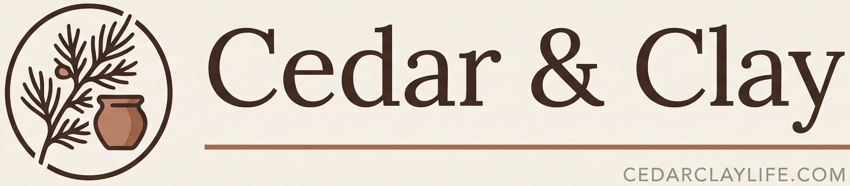
cedarclaylife.com

GARDEN PLANTS

Lily of the Valley — Price: __________
Comfrey — Price: __________
Motherwort — Price: __________
Daylilies — Price: __________
Iris — Price: __________

Seasonal availability from our acreage in Redgranite, Wisconsin.

Samantha Bergstrom
(920) 538-6638
W4187 Blackhawk Ave, Redgranite, WI 54970
cedarclaylife.com

